
BRCA NATIONAL SERIES REVIEW
2024

The 2024 National series has just finished so here is a look back on the events of all 7 rounds, the series had some fantastic moments from all of the drivers who attended.
Round 1: BLACKPOOL, The Teen Sensation!
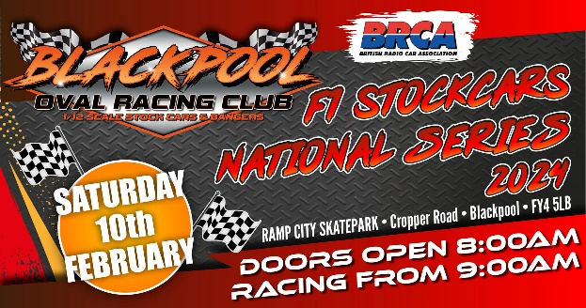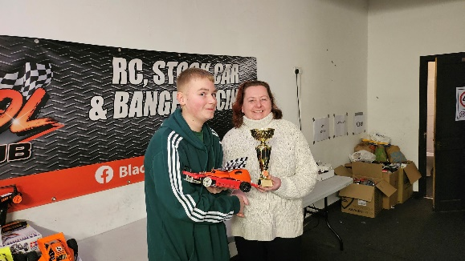
The year started off at a new venue for the F1 national series at Blackpool Oval Racing Club way back in February, for many this was to be the first time they had ever raced on this track so it always brings an element of anticipation. An important note to make is that the current National Series Champion Brandon Eccles is rumoured to be having a year out. Leaving the championship wide open for a new winner!
We were greeted with quite a large oval with plenty of space for some proper Stockcar action, and by the time we had turned some practice laps we soon found out that bumps were going to play their part during the day.
Through out the qualifying heats it became obvious that one driver stood up above the rest, F1 national series debutant and 15-year-old Noah Bailey! The young superstar had been dabbling in f1s for years but has always concentrated and dominated the f2 scene. But here at the top of the F1 national he found himself right at home.
2024 saw the return of the W/Y championship as well, won last year by Dentona regular, Andy Jacklin.
The award for round 1 was to go Matt Astbury, who seemed to have found some pace with his new car for 2024.
Heat winners throughout the day consisted of Noah Bailey, Graham and James Eccles, Steve Curley, Gary Riddell, Ian Yarwood, Matt Astbury, Alfie Jones and Ryan Cattell.
Qualifying order for the finals:
- Noah Bailey
- Ryan Cattell
- Steve Curley
- Graham Eccles
- Gary Riddell
- James Eccles
- Alfie Jones
- Ian Yarwood
- Gordon Mutch
- Sam Jacklin
- Matt Astbury
- Adam Gilbertson
- Emily Jacklin
- Lennon Cuthill
- Camron Riddell
- Peter Riddell
So, with the top 7 straight into the final it was the next 9 to fight their way through the B final, 5 minutes all out war, top 2 go through, simple….
And I must say it was a fantastic race the top 7 were separated by just 2 laps!! The top 4 were separated by half a second! At the buzzer it was to be Matt Astbury and Gordon Mutch booking their place in the final.
Next up was the junior final, it was the story of the day, as Noah Bailey raced off to win by 4 laps with 94 laps from Lennon Cuthill in 2nd with 90, 3rd was defending Junior champion Emily Jacklin on 87, Lucie Jones was 4th on 75, 5th was young Kayla Mutch from Scotland on 74, Hayden Cattell was 6th with 71, and we had Hollie-Mai Dean and Blackpool’s Amy Atkinson in 7th and 8th respectively who failed to finish. Fantastic to see 8 juniors at a national round!
Onto the main event then to finish the day, Noah Bailey was odds on favourite unless the stockcar effect could maybe trip him up, in the end the only driver able to trouble him was former national champion Graham Eccles. Noah was on fine form all day and won the race by a solitary lap with 100, Graham was 2nd on 99, 3rd was Dentona superstar Steve Curley on 98, a distant 4th was Ryan Cattell on 96 just beating James Eccles in 5th , 6th was Matt Astbury on 91, Alfie Jones was 7th on 90 laps, 8th was Gary Riddell on 88 and rounding off the result was Gordon Mutch who failed to finish.
A long but enjoyable day at Blackpool, the racing was fast and enjoyable. Noah Bailey had arrived; the statement was made loud and clear and he walked away at the summit of 1/12th F1 stockcar racing in both senior and junior series.

Round 2: Rugby, English Open Championship
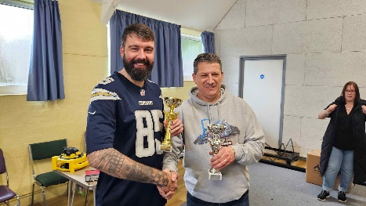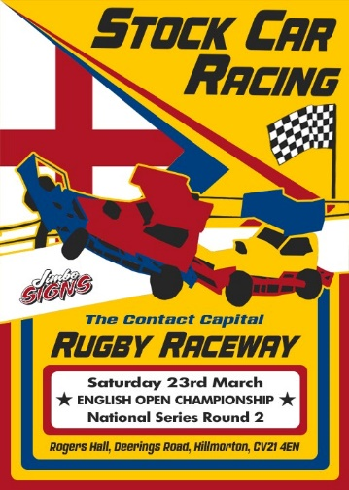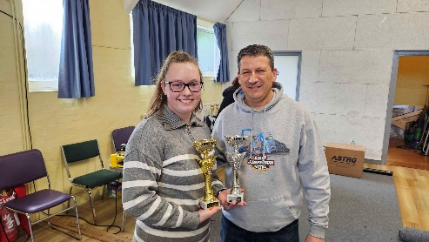
We arrived at the Contact capital for round 2 of the national series which also doubled as the English open, this meant the winners of todays finals could sport the st George’s flag on their roof for the next 12 months. Last years winner Anthony Wyper was not booked in so a new name would go onto the roll of honour, however the junior champ was! Emily Jacklin was here and ready to jump start her season after a tough day out at Blackpool previously.
The day started off with the W/Y championship, in which 15-year-old Lucie Jones came out on top to take home the award, last years runner up was on form on her home track.
Onto the qualifying heats, the winners through the day were, Emily Jacklin, Richard Harding, Ryan Cattell, Ben Harding, Noah Bailey, Stuart Clarke, Alfie Jones, Steve Curley, Owen Bates, Tim Bailey and Lennon Cuthill.
Qualifying order for the finals:
- Ryan Cattell
- Noah Bailey
- Ben Harding
- Rich Harding
- Steve Curley
- Emily Jacklin
- Alfie Jones
- Stuart Clarke
- Owen Bates
- Lennon Cuthill
- Tim Bailey
- Gary Riddell
- Max Harding
- Camron Riddell
- Sam Jacklin
- Brandon O’Neill
The B final up first, a scrappy affair as the race hotted up to join the finalists, but it was Owen Bates who pulled 3 laps clear by the end winning with 95 laps, the fight for 2nd was sliced only by 0.7 seconds as Stuart Clarke pipped Gary Riddell both on 92 laps, 4th was Brandon O’Neill on 91 laps as was Tim Bailey in 5th. Lennon Cuthill was 6th on 90laps, Camron Ridell and Max Harding finished on 88 in 7th and 8th and Sam Jacklin in 9th on 59 with some mechanical issues.
In the juniors we had a consolation race for the first ever time because the entry list had an all-time best turnout for juniors at a national series event! 4 drivers lined up with the top 2 progressing, Hollie Mai Dean took a well-earned victory on 79 laps from young Hayden Cattell on 78.
The English Junior Championship Final was all set and ready to be a classic, and that it was, the top 4 all in contention, at the buzzer it was to be a successful title defence Emily Jacklin who was actually only 1 second ahead of Noah Bailey on the road, she won the race with 89 laps, Noah ended up on 88 by finishing 0.002 seconds after the buzzer! Lennon Cuthill was 3rd on 86 and Lucie Jones 4th on 84 laps. 5th place went to Oscar Harding on 79 laps, 6th and 7th went to Hollie-Mai Dean and Hayden Cattell respectively on 71 and 67 laps, and then we also had Zella Harding and Amber Sutton in 8th and 9th to round off a great day for the youngsters and future of our sport!
A final time, and a new English open Champion is to be crowned. Now this race ended up being a Rugby special. The track lends itself to some stockcar racing and it kicked off right from the start. Ryan Cattell and Owen Bates found themselves right at the back from the start, as Emily Jacklin and Steve Curley lead early on. As the race progressed though it was Rugby regular Alfie Jones who had dialled in some speed who led from arguably the greatest of all time Ben Harding heading into the latter stages. But this is stockcar racing and it is never over until it’s over, and with 6 seconds to go a pile up going into turn 3 took Alfie wide and it was Ryan Cattell who had snuck through into the lead. Alfie was quicker but just had no time to get the hit in. So, at the end it was Ryan Cattell in 1st with 99 laps 0.3 seconds ahead of Alfie Jones in 2nd, 3rd was Ben Harding on 98 laps, 4th was Stuart Clarke on 95 as was Rich Harding in 5th, 6th went to Emily Jacklin on 94, Noah Bailey was 7th on 91 laps, Steve Curley was 8th on 85 laps and 9th was Owen Bates on 84.
After 2 rounds then the series was beginning to shape up, the W/Y championship was now being led by Lucie Jones with Brian Cuthill not far behind, the gap had been cut in half in the junior championship was Emily Jacklin, but Noah Bailey still leads the way. The overall national standings now saw Ryan Cattell on top by 5 points from Noah Bailey, with Alfie Jones and Steve Curley in 3rd and 4th, not far behind.

Round 3: Walsall, British Championship
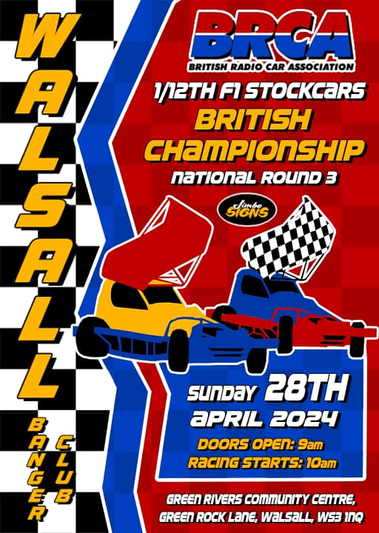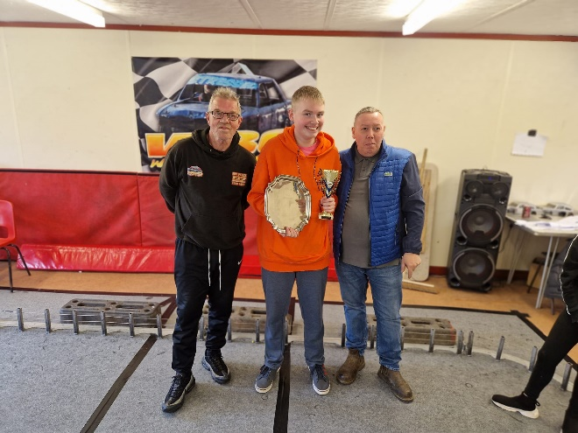
After some off-track business had been handled, the series then diverted last minute to another new track for the F1 stockcars in the form of Walsall Banger Club, the west midlands club has a great reputation for its quality venue and track layout, so what a perfect leveller for the first major championship of 2024!
Championship leader Ryan Cattell was not in attendance this weekend but the biggest news was that the defending British Champion and current silver roof Brandon Eccles was!
The W/Y championship had a bye so it was all eyes on the black and white chequered roofs for senior and juniors.
The heat winners were, Noah Bailey, Brandon Eccles, Emily Jacklin, Anthony Wyper, Graham Eccles, James Eccles, Gary Riddell, Steve Curley and Ben Harding.
The British Championship has a slightly different format to a regular national, the top qualifier is placed directly on pole for the final, this being Brandon Eccles, returning to the top like he had never been away. The next 17 drivers are split into 2 semi-finals.
Semi 1:
- James Eccles
- Graham Eccles
- Alfie Jones
- Ben Harding
- Steve Curley
- Owen Bates
- Tommy Johnson
- Graeme Beckett
The winner by a sizeable 6 laps was James Eccles from pole position on 107 laps, joining him in the final all on 101 laps were Steve Curley, Graham Eccles and Tommy Johnson, Alfie Jones just misses out in 5th on 100 laps, Ben Harding was 6th on 99 beating Owen Bates in 7th by 1.2 seconds, and in 9th was Graeme Beckett on 95 laps.
Semi 2:
- Noah Bailey
- Anthony Wyper
- Emily Jacklin
- Gary Riddell
- Rich Harding
- Lennon Cuthill
- Matt Philpott
- Brian Cuthill
This was a much closer race with only 2 laps separating the top 6. At the buzzer it was a brilliant win for the Scottish junior ace Lennon Cuthill on 105 laps, 2nd 3rd and 4th all separated by less than 2 seconds, Noah Bailey, Rich Harding and Matt Philpott securing their place in the final on 104 laps, Emily Jacklin just misses out along with former champion Anthony Wyper on 103 laps, a dnf for Gary Riddell in 7th on 90 laps, and Brian Cuthill round it off in 8th with 89 laps.
The British Junior Championship Final 2024, a relatively small grid compared to rounds 1 and 2 saw 6 cars fight it out for the coveted title. Noah bailey romped away with the win and retaining his title from last year by 5 laps on 104, Emily Jacklin settled for 2nd on 99, Lennon Cuthill was 3rd on 96 laps, Lucie Jones was 4th on 92, Oscar Harding was 5th on 85 and 6th was Zella Harding on 76 laps.
The British Championship Final 2024, I can only wish I was there to witness this race live! The top 3 separated by 0.55 seconds! 2nd and 3rd crossed the line side by side! And it is a massive congratulations to Noah Bailey, one of the youngest ever winners of the British Championships in 12th stockcar history on 104 laps, James Eccles held on for 2nd by the width of his bumper from Brandon Eccles in 3rd. The split times for clarity were, Noah, 300.84, James 301.35 and Brandon 301.39! Incredible. 4th was Lennon Cuthill, 5th was Steve Curley and 6th was Matt Philpott all on 102 laps, 7th went to Rich Harding on 100 laps, 8th was Tommy Johnson on 91 laps and pulling off early with a mechanical failure was Graham Eccles on 29 laps.
A massive thankyou to Walsall Banger Club for hosting at such short notice, the F1s will return! Noah Bailey returns to the top of the National Series and also continues to lead the junior series with a perfect day out.

Round 4: Burton, The Rivalry Returns
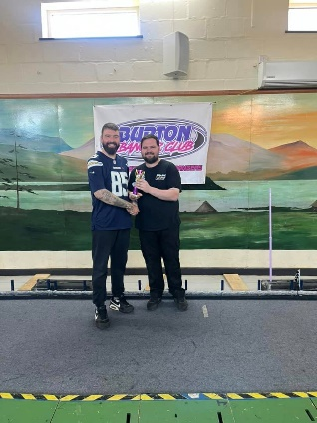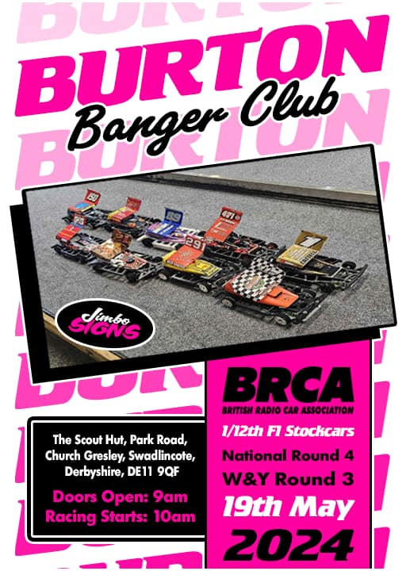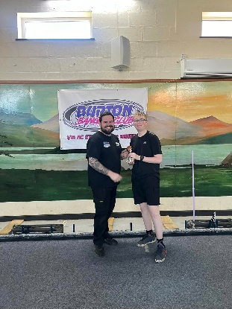
Passing the half way point in the national series now as we head to Burton Banger Club for round 4. People will recognise this track from the 2023 British champs held at the charged rc show in Blackpool, although this configuration is a longer version, Burton also host the newly formed Master of Shale event late in the year as well.
The W/Y championship returned and kicked us off, Lucie Jones taking the honours again and maximum points.
Onto the main meeting qualifying heats, the winners during the day were, James Eccles, Noah Bailey, Graham Eccles, Ryan Cattell, Gary Riddell and Emily Jacklin.
For the finals they lined up as:
- Noah Bailey
- Ryan Cattell
- Graham Eccles
- James Eccles
- Emily Jacklin
- Rich Harding
- Tim Bailey
- Steve Curley
- Gary Riddell
- Sam Jacklin
- Ben Harding
- Alfie Jones
- Lennon Cuthill
- Graeme Beckett
- Lucie Jones
- Brian Cuthill
First up was the last chance qualifier to make the main event, top 2 to progress.
The track lends itself to some super-fast close racing, and at the end it was another close one! The top 3 all on 102 laps, 1st was Gary Riddell with a split of 300.303, 2nd was Ben Harding on 301.09 and 3rd and just missing out was Steve Curley with 302.464, 4th place went to Lennon Cuthill on 100 laps beating Alfie Jones in 5thalso on 100 laps, 6th was Graeme Beckett on 95 laps as was Lucie Jones in 7th, 8th was Sam Jacklin on 86 with 9th place Brian Cuthill on 82.
The Junior Final was a story of 2 races, the first race had Noah Bailey in it, and that was it, who managed to avoid almost every incident to win the race by 10 laps on 107, the 2nd race was everyone else, in 2nd place and a first junior podium of 2024 goes to Lucie Jones on 97 laps, 3rd place was Emily Jacklin on 95 laps beating Lennon Cuthill in 4th place by 0.1 seconds, a superb 5th place for young Zella Harding on 81 laps, 6th was Hollie-Mai Dean on 75 and Joel Brown was 7th on 54 laps.
The final as the title suggests is the return of the rivalry, there seemed to be 3 main protagonists that had silver on the brain, it was a super close race and then with 30 seconds to go it all kicked off, in true stockcar fashion the bumpers were flying in everywhere, and by the end, many had no idea who finished where. At the buzzer it was a very relieved Ryan Cattell in 1st with 109 laps, 2nd place went to Noah Bailey on 107 from James Eccles only 0.08 seconds behind and Emily Jacklin in 4th, a further 0.09 seconds back! 5th place on 104 was Gary Riddell as was 6th place Graham Eccles, Tim Bailey was 7th on 103 and the Harding Brothers of Ben and Rich were 8th and 9th respectively on 101 laps.
At the end of play the W/Y series saw Lucie Jones extend her lead to 6 points over Brian Cuthill. The Junior series had Noah Bailey in charge as well as the main national series too. Next stop, Scotland!

Round 5: Coaltown, North of the border
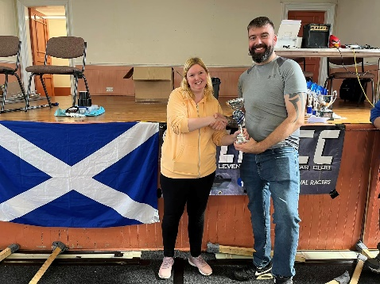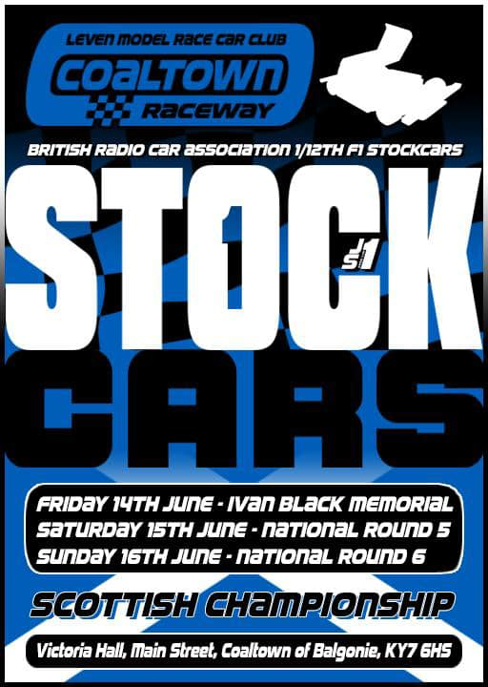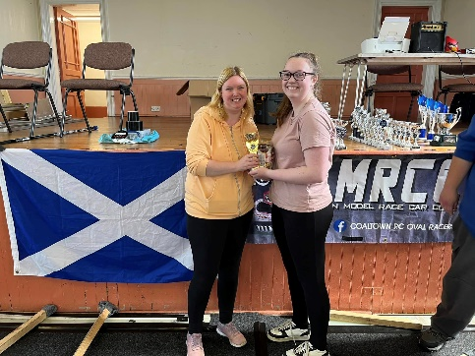
The much-anticipated return to Scotland was upon us, last year was an Eccles family rout with the brothers of James and Brandon wiping the floor with us all. Scotland can make or break your season, its such an important part of the calendar. And an amazing weekend away that I urge more drivers to consider in the future.
The weekend kicked off on the Friday night with the traditional Ivan Black memorial meeting. Ivan was a much-loved friend on the 1/12th oval scene who tragically passed away whilst travelling to holland a number of years ago. This event was won by Ryan Cattell who wins it for the first time in his career.
We kicked off in usual style on Saturday with the W/Y championship, this was won by local driver Mark McCabe.
Heat winners of the day were, James Eccles, Graham Eccles, Alfie Jones, Ryan Cattell, Steve Curley and Emily Jacklin.
The order after Qualifying was:
- Ryan Cattell
- James Eccles
- Graham Eccles
- Emily Jacklin
- Alfie Jones
- Noah Bailey
- Steve Curley
- Gary Riddell
- Lennon Cuthill
- Graeme Beckett
- Brian Cuthill
- Camron Riddell
- Sam Jacklin
- Mark McCabe
- Lucie Jones
- Andy Jacklin
The racing all day was super close, the quality of driving was fantastic along with the new carpet the club had invested in. A tough race to win is a national round consolation, but not a problem for local junior superstar Lennon Cuthill winning on 100 laps from Sam Jacklin in 2nd on 98, these progress to the main event later on. 3rd place went to Lucie Jones on 94 laps beating both Mark McCabe and Gary Riddell on split, 6th place went to Graeme Beckett on 93 laps, 7th was Camron Riddell on 91, Brian Cuthill was 8th on 90 and Andy Jacklin was 9th on 89 laps.
The junior Final was up next, a full grid of 9 cars which was led home by Emily Jacklin by 3 laps on 101, 2nd place went to Noah Bailey on 98 laps, 3rd was Lennon Cuthill, 4th place went to Scotland debutant Oscar Harding with 85, 5th was Hollie-Mai Dean on 81, Hayden Cattell was 6th on 68 laps with Molly Harding on 64 in 7th, Young rookie Cole Tucker drove well to finish 8th on 54 laps and a mechanical failure put Lucie Jones down in 9th on 52.
Final time and it was fast! Everyone on pace and it was bumper to bumper action for the whole 5 mins. At the buzzer it was Ryan Cattell who wins on 111 laps, 2nd place was Graham Eccles showing his son James how it is done by 0.2 seconds with 109 laps. In fact, 2nd through to 5th all had 109 laps with Emily Jacklin and Steve Curley 4th and 5th respectively, 6th place went to Alfie Jones on 107, Lennon Cuthill was 7th on 104, 8th place and a tough day for championship leader Noah Bailey with 103 and Sam Jacklin 9th on 92 laps.
As day 2 of the Scottish weekend winds down and most of us headed off the Cowdenbeath for some full size racing the situation was this, Lucie Jones had extended her lead to 8 points in the W/Y Championship. Emily Jacklin clawed back some much-needed ground in the juniors, Noah Bailey was still clear in the main series but the pack were closing in. As 5 rounds were complete it meant that drop rounds will begin to play a part in the series from now on.

Round 6: Coaltown, 3 Champions in 1 day
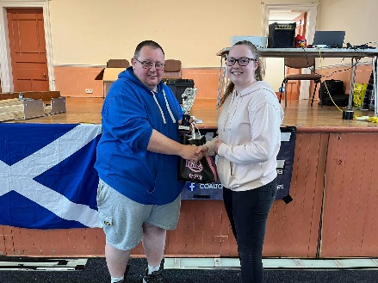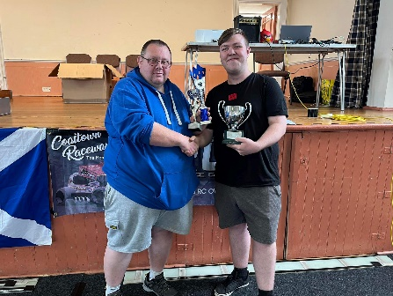
Dawn broke over the beautiful Scottish landscape for day 3, ahead of us was not only round 6 of the national series but also the Scottish Open championship 2024, last years winner Brandon Eccles was probably at a Brisca F1 meeting taking a beer selfie, but Junior Champ Emily Jacklin was booked in and ready to go.
The W/Y series started us off with Brian Cuthill taking his first win of the season on home soil but note that Brian has been no lower than 3rd all year! Great consistency.
The heat winners today were, James Eccles, Graham Eccles, Ryan Cattell, Alfie Jones, Lennon Cuthill, Gary Riddell and Emily Jacklin.
So, for the finals the order was:
- James Eccles
- Ryan Cattell
- Lennon Cuthill
- Graham Eccles
- Noah Bailey
- Alfie Jones
- Emily Jacklin
- Steve Curley
- Gary Riddell
- Sam Jacklin
- Camron Riddell
- Iain Roper
- Brian Cuthill
- Lucie Jones
- Mark McCabe
- Peter Riddell
Consolation up first and a good win for Steve Curley on 105 laps, Gary Riddell finished 2nd on 102, missing out on progression was Camron Riddell on 101 in 3rd, 4th was Lucie jones with 97 laps, 5th was Brian Cuthill on 95, Peter Riddell was 6th on 87, we then had three dnf with Sam Jacklin, Iain Roper and Mark McCabe all pulling off with mechanical issues.
Junior Scottish final time, this was a battle, I wasn’t sure at all who had got this one, but at the end it was another title defence for Emily Jacklin, retaining her st Andrews flag with 100 laps, from Noah Bailey in 2nd with 99, 3rd was Lennon Cuthill on 97 laps, then a bit of a gap to 4th with Oscar Harding on 90 laps, Lucie Jones struggled in 5th with 89, Hollie-Mai Dean was 6th with 80 laps, post-race scrutineering shadowed the result a bit with Hayden Cattell being disqualified and demoted to 9th scoring 77 laps, but that made the way for Molly Harding to move up to 7th also on 77laps, young Cole Tucker is awarded 8th with 64 laps.
Scottish Open final 2024, and we have a new Scottish open champion and first-time national winner in the shape of James Eccles, big congratulations to one of the nicest lads on the ovals who has been so close to so many wins. The smile said It all as James wins in style on 111 laps from Ryan Cattell in 2nd on 108 only 0.1 seconds ahead of Graham Eccles in 3rd, 4th place is Emily Jacklin on 106 laps, 105 laps see Alfie Jones beat Noah Bailey by 1.5 seconds in 6th, 7th went to Lennon Cuthill on 102, Gary Riddell was 8th on 100 laps and 9th with a steering issue was Steve Curley on 97 laps.
The curtain closes on 2024s visit north of the border to bonnie Scotland, and with that, the end of the national grading period. And with her performances being so good, Lucie Jones is promoted to blue grade, meaning Brian Cuthill can no longer be caught by any driver in the W/Y championship as long as he races at the final round. Not taking away from the achievement as Brian has been up there all year long. Ryan Cattell is also confirmed the National Points Champion for 2024 and will wear the silver roof. The junior series on the other hand is coming down to the wire. After back-to-back finals in Scotland Emily Jacklin has cruised back up behind season long leader Noah Bailey, and will go head-to-head with the British Champion on her home track at Dentona at the season finale!

Round 7: Dentona, Drama at the Finale
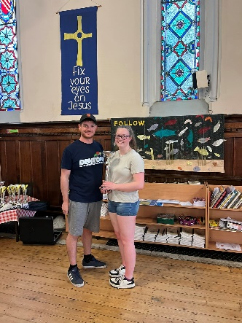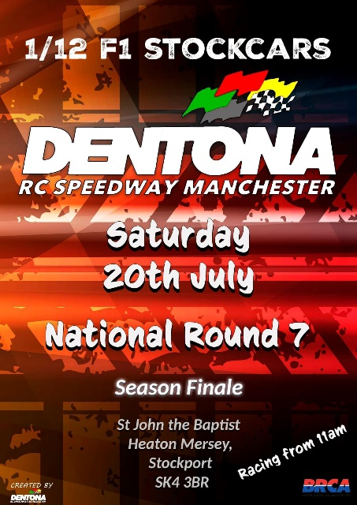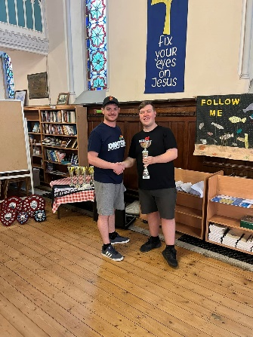
A condensed National series this year means we are in July and at the final round of 2024. Here at Dentona is an intriguing round as this is the venue of the 2024 1/12th F1 Stockcar World Championships in November. But right now, it’s the time and the place to settle the junior national championship fight!
W/Y championship up first and it’s the first win of the year for Graeme Beckett on his home track.
The heat winners of the day were, Ryan Cattell, Noah Bailey, Graham Eccles, James Eccles, Steve Curley, Matt Philpott and Emily Jacklin.
Qualifying order was:
- James Eccles
- Anthony Wyper
- Ryan Cattell
- Matt Philpott
- Noah Bailey
- Graham Eccles
- Steve Curley
- Emily Jacklin
- Sam Jacklin
- Graeme Beckett
- Gary Riddell
- Lennon Cuthill
- Stuart Clarke
- Brian Cuthill
- Matt Astbury
- Alfie Jones
The first half of the B final was as close as it gets with multiple drivers moving up and down the order, it wasn’t until late on that Alfie jones rose to the top and pulled clear on 101 laps, Stuart Clarke followed him through to finish 2nd on 100, 3rd place went to Lennon Cuthill with Emily Jacklin 0.19 seconds behind both on 97, Sam Jacklin was 5th on 94, 6th 7th and 8th all had 90 laps, in the shape of Matt Astbury, Gary Riddell and Graeme Beckett and 9th place was Brian Cuthill.
The Junior final was up next, parents had sweatier palms than their kids who were racing! Emily had to win, Noah, had to win or finish 2nd, the points from the heats were going to matter. Even from all 6 of the previous rounds, every point matters in the national series. We all watched with baited breath as the countries top 2 went at it, navigating the traffic and the incidents, at the end it was Emily Jacklin taking her 4th junior final win of the season on 98 laps, 2nd place was Noah Bailey on 97, 3rd place was Lennon Cuthill on 93 laps, 4th went to Lucie Jones on 84, 5th was Hollie-Mai Dean on 79 laps, Chloe Mitchell ended her only appearance this season with 6th on 72 laps, Cole Tucker was 7th on 58 laps, and Hayden Cattell who raced with a broken baseplate all day held on with 43 laps in 8th. So, with the results in and the points were added up it came about that Emily and Noah had managed to tie on points, so the committee went outside to discuss. It was decided that the fairest and only course of action was for the 2 superstars share the title of national junior points champion for 2024! They will there for be able to run a split wing with half silver for 2025 in recognition of their amazing results this year! Congratulations both of you!
The final final of 2024 in the National series ended up being one of the roughest all season long. But again, James Eccles was the man to beat, and no one could! A comfortable win at the end with 111 laps, 2nd went to Noah Bailey on 109, Ryan Cattell almost a lap back but also on 109 in 3rd, Graham Eccles was 4th on 108 laps, Anthony Wyper was 5th on 103, 6th was Steve Curley on 102, Matt Philpott was 7th on 101, 8th was Alfie Jones on 100, and finishing off the final in 9th was Stuart Clarke on 95 laps.
Thankyou to all of the drivers who have participated in this year’s series, and to the clubs for hosting us. Congratulations to all of our winners. We look forward to seeing you all and more at the world championships at Dentona in November.

F1 Class rep
Ryan Cattell
